## Result analysis

r2=r2*1.13

Dosage: B. S 0.1 g/L, N. SP 0.2 g/L.

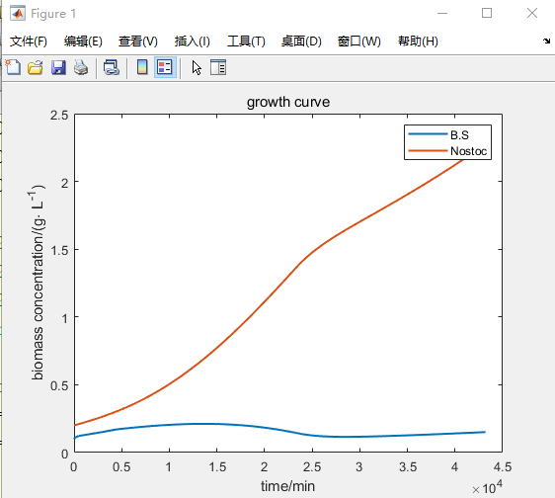

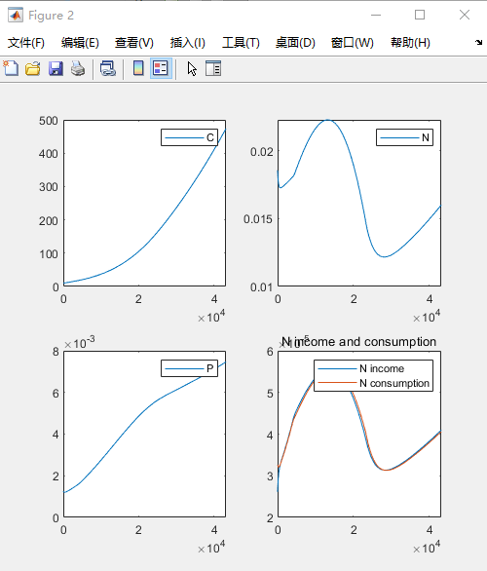

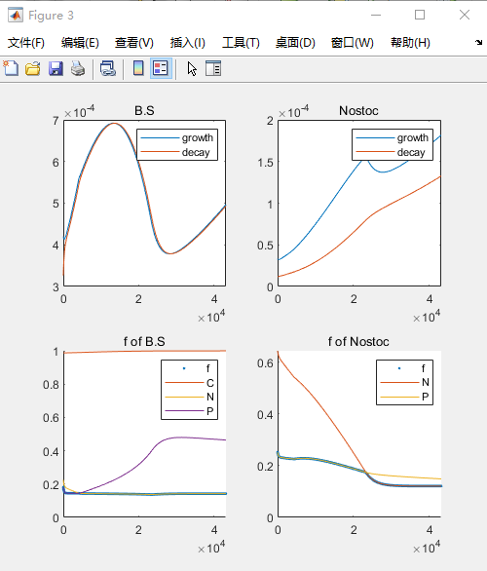

In the beginning, both B. S. and N.sp will be limited by P resources, and the two organisms will grow slowly temporarily. However, P concentration will continue to increase with the phosphorus dissolution of B.S. Therefore, the restriction on B.S quickly changed from P to N and reduced the restriction on P of N.sp to a certain extent. N.sp keeps growing faster. The rapid growth of N.sp leads to large consumption of N, and the resource of N tends to decline on the 16th day. B.S was restrained by competition of N and The fBS decreases slowly, biomass gradually decreased after reaching its peak.   
With the consumption of N, N replaces P to limit the growth of N.sp on the 16th day, and the growth rate of N.sp decreases(an obvious turning point on the 16th day). The biomass of B.S reached the lowest, and the N limitation became smaller, fBS increases slowly. This allows B.S to grow again and makes the amount of N resources rise. Eventually, both B.S. and N.sp can achieve a steady growth trend, and various resources can also rise steadily.

**参数敏感性分析**

Morris screening method, which was proposed by Morris in 1991 and improved by Campolongo et al., is a global sensitivity analysis method which is widely used at present. The basic idea of the Morris screening method is to select a variable in the model to perturb slightly in the whole change range, while other variables remain unchanged, and evaluate the output response change caused by the small change of the variable, that is, the concept of basis effect proposed by Morris screening method.

**Pf溶磷速率**

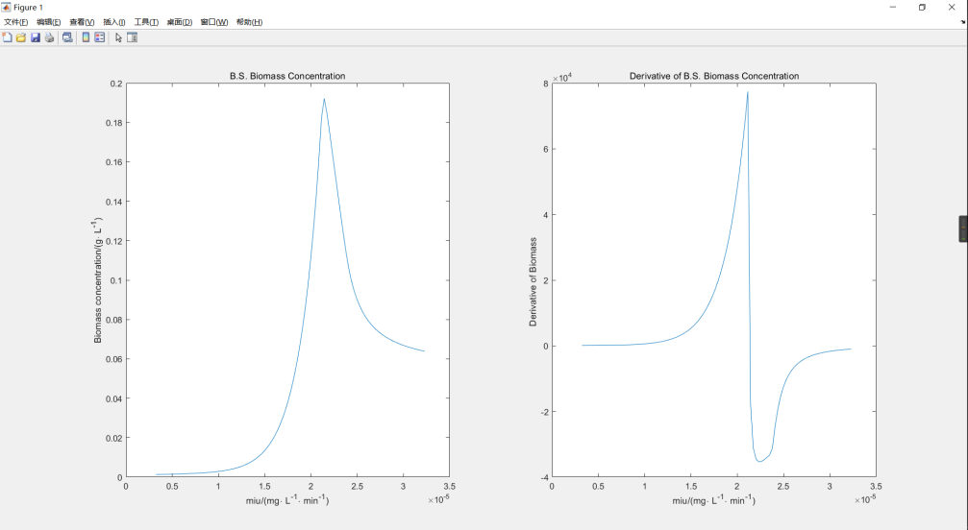

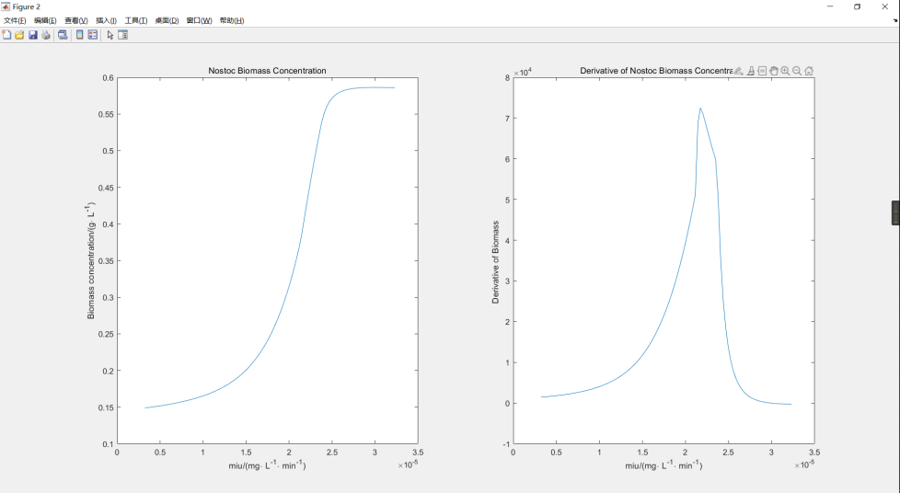

### We analyzed the phosphorus dissolving rate of Pf by the Morris screening method. With the increase of phosphorus dissolution rate, the change of B.S biomass was first positive, then negative, and finally approached 0, while the change of N.sp biomass first increased and then decreased, which was always positive.

### Explanation: A faster phosphorus dissolution rate could alleviate the p-limitation experienced by B.S and N.sp at an early stage. After exceeding a certain threshold, due to the early arrival of the N-limiting stage, the fast-growing N.sp inhibits the growth of B.S by competing for N, and this effect will gradually flatten out.

**氮矿化速率**

When the nitrogen mineralization rate is low, the derivative of B.S biomass to nitrogen mineralization rate is positive, and the derivative of N.sp is negative. With the increase of nitrogen mineralization rate, the derivative gradually approaches and reaches 0. The length of this process is related to the time of the target point.

Explanation: A higher nitrogen mineralization rate allowed B.S. and N.sp to enter the N-limiting stage later. B.S. without timely N-limiting would have a higher growth rate and inhibited the growth of N.sp by competing for P. When the nitrogen mineralization rate increases to a certain value, the N-limiting stage will be completely lifted and the growth condition will not be changed.

**m1**

m1 describes the natural mortality rate of B.S. (including sporulation), and it is worth noting that after B.S. dies/sporulation, this part of resources cannot be utilized temporarily.

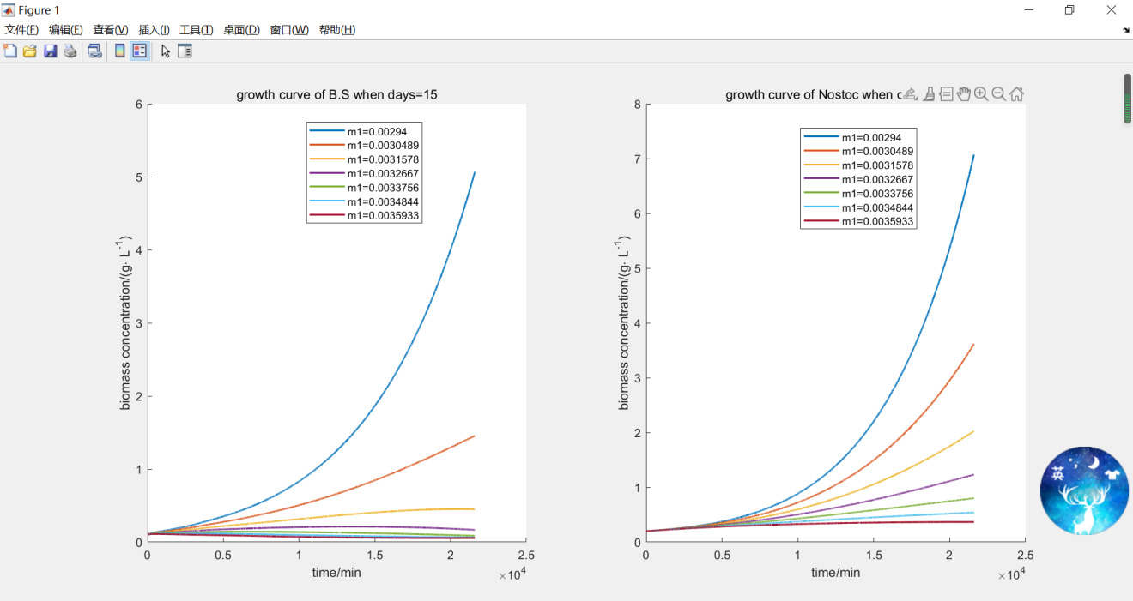

The biomass of B.S and N.sp decreased with the increase of m1. This is because the increase of m1 limits the growth of B.S and promotes the loss of resources.

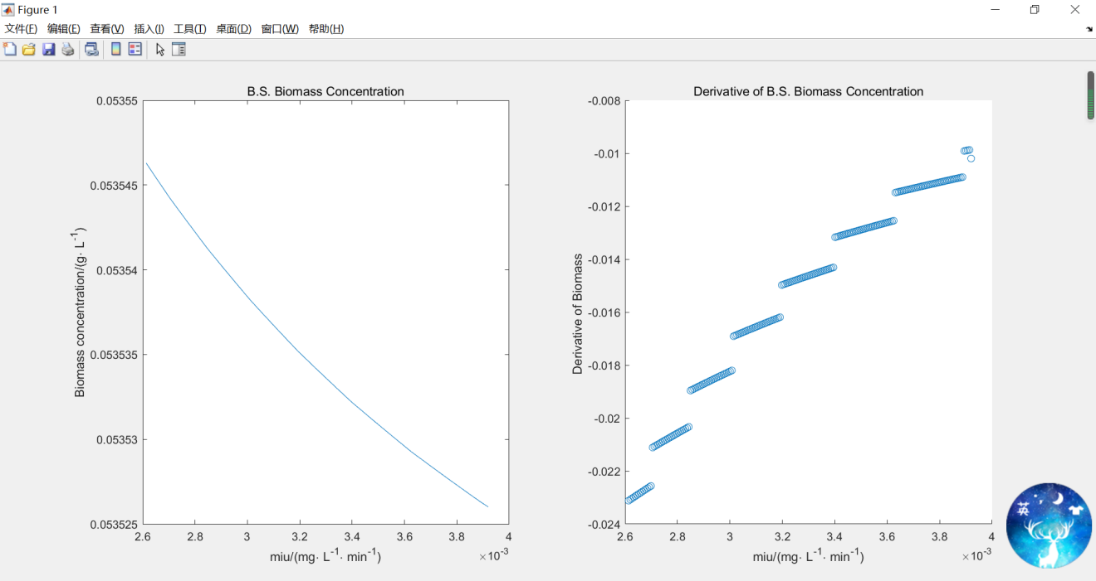

(这个部分要不要？)

With the increase of m1, the biomass of B.S decreased steadily. It is worth noting that the ratio of biomass change to m1 change is discontinuous.

**KP和KN**

Kn and Kp describe the degree of resource demand of the two species. The larger these values, the higher the demand for such resources. When Kn1 and Kp1 are mentioned, they refer to the demand of B.S for N and P, while Kn2 and Kp2 for N.sp.

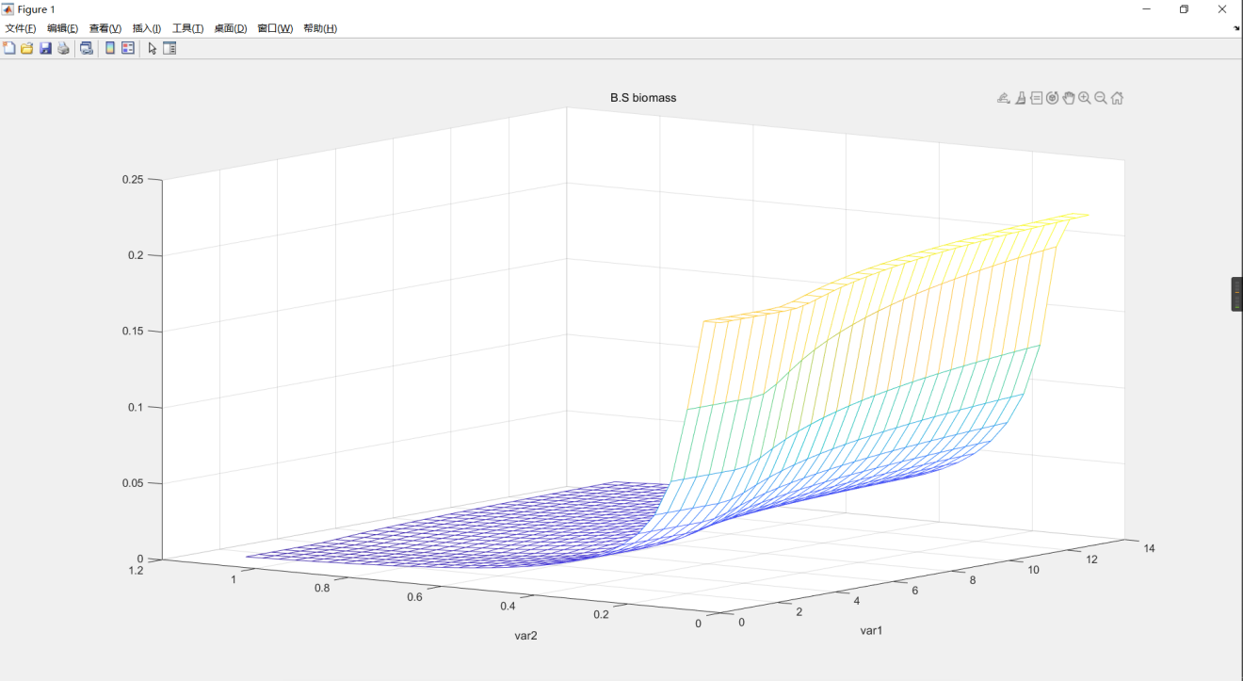

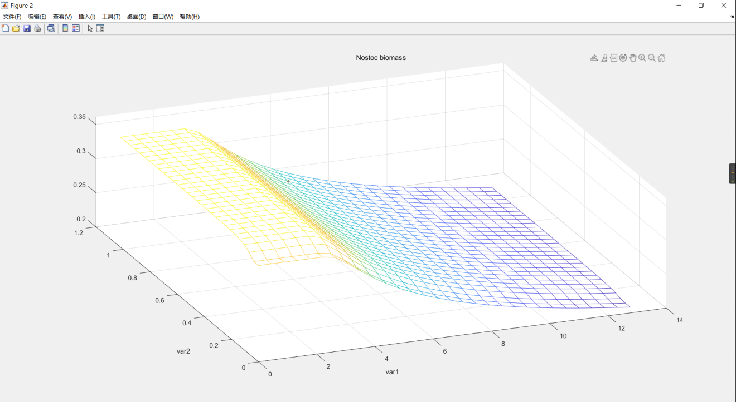

Kp1 in Kn1 and Kp1 will have a greater influence on B.S; The smaller Kp1 is, the weaker P restriction B.S is, and it decreases to a certain extent. Because of N restriction, B. S enters the platform period. That B.S is sensitive to the change of Kp1.

Kn2 in Kn2 and Kp2 will have a greater influence on N.sp; It shows that N restriction has a strong influence on N.sp. The larger Kn2 is, the more severe the n restriction on N.sp is.

（但上面那个图比较难看懂，且只有自己的K对自己的作用）

把KN拿出来说：

KN2 increased, B.S biomass increased and N.sp biomass decreased gradually. The larger KN2 is, the more severe the n restriction on N.sp is. With the increase of KN1, the biomass of B.S and N.sp decreased gradually. B.S has limited growth and insufficient resources.

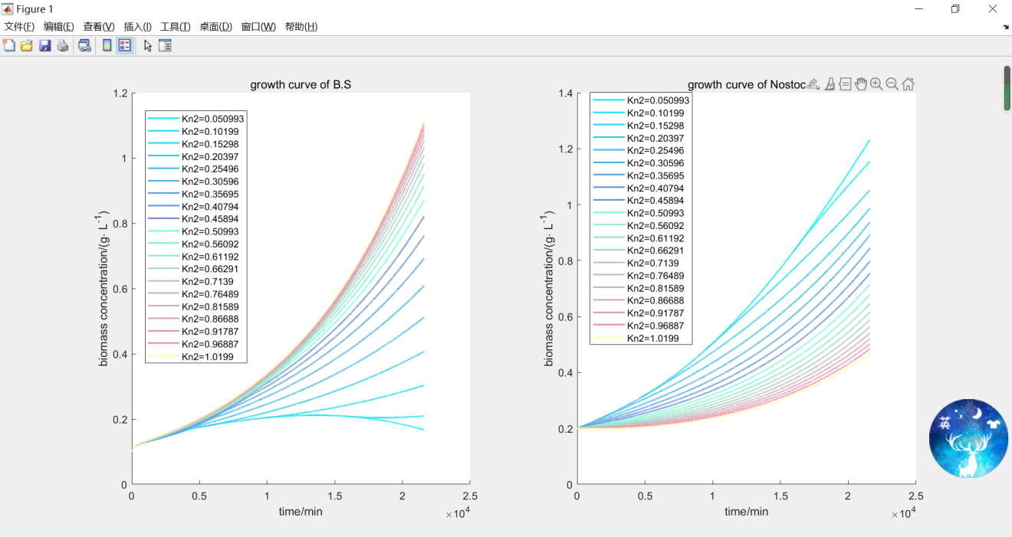

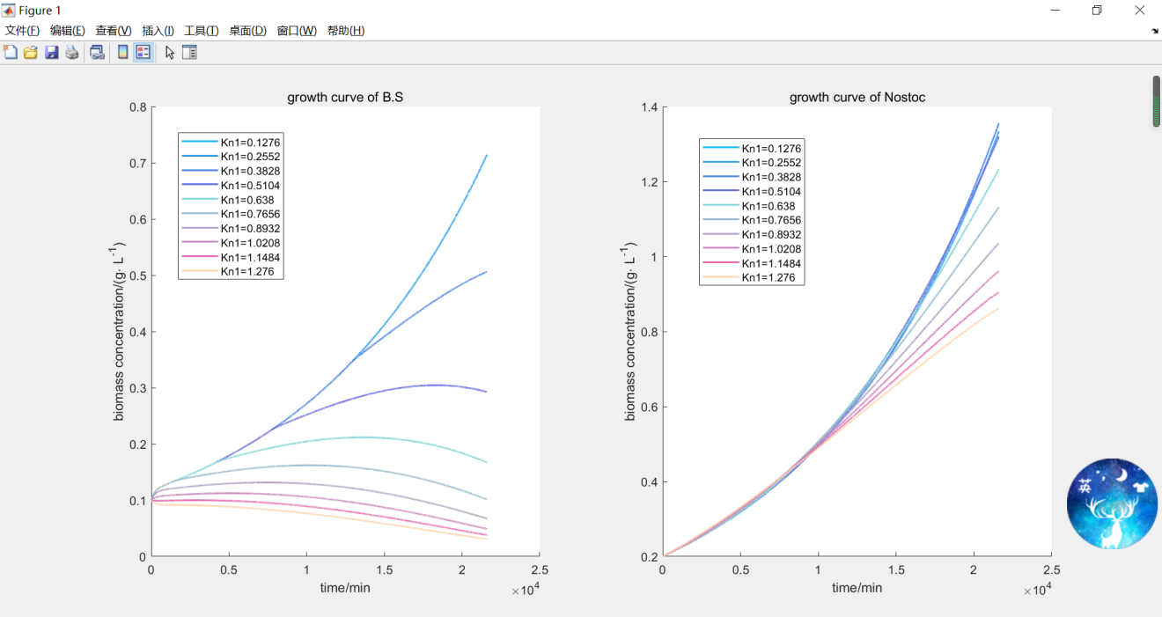

**生物量投放（初值影响）**

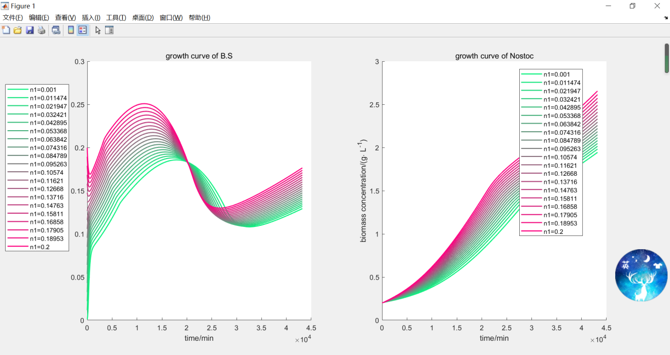

When the dosage of N.sp is fixed to 0.2, the biomass of B.S is adjusted in the range of 0-0.2 g/L.

B.S generally keeps the trend of increasing first, then decreasing and finally increasing again;

When the initial quantity exceeds 0.15, the initial resource quantity is insufficient, which will decrease first and then increase; When the initial quantity is low, it will increase rapidly to a higher level, and then increase first, then decrease, and finally increase again.

It is easy to understand that the final biomass of B.S and N.sp is directly proportional to the initial dosage of B.S.: The more the number of B.S, the greater the performance of the promotion of resources.

(用这个的话还要再补数据？)